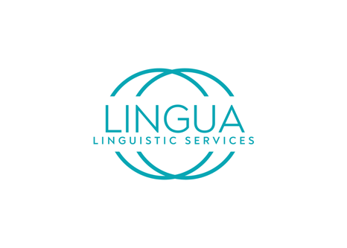

Lingua.GM Community Interpreting/Translation Referral Form
Please complete as much of the information required as you can for your referral. We will get in touch with you as soon as possible. We are continuing to operate as a hybrid service and offer telephone, online and limited face-to-face interpreting/translation.
Due to the unprecedented situation, we find ourselves in with COVID 19, and to ensure that we follow Government guidelines in relation to suitable Interpreter provision, along with travel and social distancing restrictions, we are advising that interpretation should be conducted via telephone or video. This is to reduce the potential risk to all concerned and avoid possible further spread of the virus.

Referral Details
Tell us how you were referred to lingua.GM
Date
Referrer
Referrer Contact Details
Self-referral

Please state the language for interpretation you require to begin:
Language:
Type of Interpretation:
Face to Face
Online
Video

Risk Assessment Info
In cases where there are clinical reasons why a Face-to-Face appointment is necessary, (and telephone or video are not suitable), personal protective equipment must be provided to the Interpreter and a Risk Assessment must have taken place, documented, and a copy filed in the patients notes. If you have not completed a Risk Assessment for a Face-to-Face appointment then you can request this from our services for the Risk Assessment Form at info@linguagm.com If you have not completed a risk assessment, please choose an alternate type of interpretation as we cannot perform face to face without the form.

Client's Details
Surname
First Name
Address
Postcode
Date of Birth
Age
Gender
Telephone Number
Preferred Language
Language Spoken at Home
Emergency Contact Person: Name
Telephone
Country of Birth
Preferred language or Need for Interpreter

